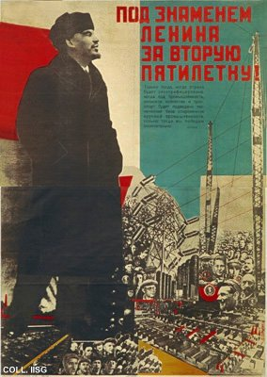 |  | Sergej Senkin, 1931  Under Lenin's banner for the second Five Year Plan!  Publisher: Ogiz-Izogiz, Moscow/Leningrad  (Lithography, 142.5x100 cm., inv.nr. BG M1/136)  An ode to industrialization and electricity in the name of Lenin. Senkin, the designer, often cooperates with Klutsis and is clearly influenced by him.  A full colour postcard reproduction of this poster is available. See the postcard reproductions-page on this site.

