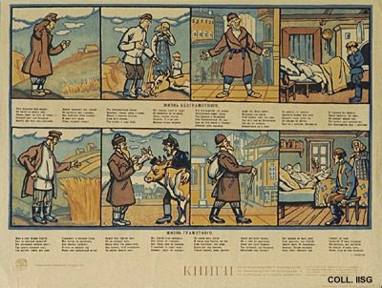 |  | Aleksei Radakov, 1920  The life of the illiterate - The life of the literate  Publisher: Gosizdat, Petersburg  (Lithography, 51x68 cm., inv.nr. BG E11/742)  The illiterate farmer, on top, has a poor harvest. His cow dies, he does not know the way in town and dies in poverty, leaving a young child. The literate farmer has read how to improve his harvest and knows where to buy a good cow. When he dies, his son is older and able to take over the farm. Note the bookshelf in the last picture.

