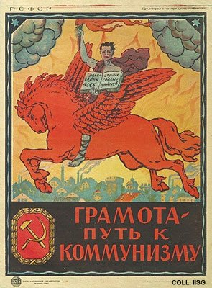 |  | Designer unknown, 1920  Literacy is the path to communism  Publisher: Gosizdat, Moscow  (Lithography, 72x54 cm., inv.nr. BG E11/746)  In its first years, the communist regime organizes extensive campaigns to combat illiteracy. This poster uses the classical symbol of the winged horse Pegasus as distributor of knowledge. The text in the book reads 'Proletarians of all countries ...'  A full colour postcard reproduction of this poster is available. See the postcard reproductions-page on this site.

