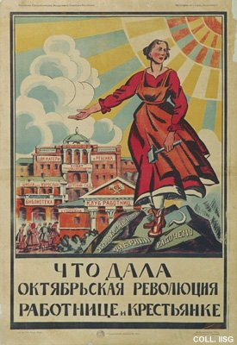 |  | Designer unknown, 1920  What the October Revolution has given to working and peasant women  Publisher: Gosizdat, Moscow  (Lithography, 106x73 cm., inv.nr. BG L3/212)  The woman gestures towards a library, a mensa, a workers club, a school for adults and a 'house of mother and child'. The 'October Revolution' is nowadays usually referred to as the November Revolution, due to differences in calendar systems.

