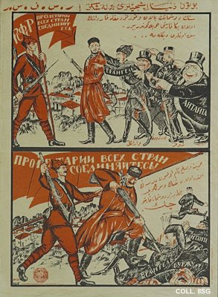 |  | Nikolay Kogout, 1920  Your enemies want to send you to war against me, your brother, by deceit and intimidation. Do not listen to them! If you want peace and freedom, take up your rifle with me and beat your enemies.  Publisher: Revvoensovet, Moscow  (Lithography, 83x60 cm., inv.nr. BG E11/737)  Poster with text in Tatar, meant for distribution in the Crimea. The Tatars are to fight on the Red side against the White generals Vrangel and Joffre, who are pictured as the accomplices of bourgeoisie and capitalism.

