Foreign imperialists

After the start of the Korean conflict, the United States became China's main foreign adversary. The war provided numerous opportunities to show Americans in an extremely unfavorable light. A recurring theme was the accusation that America engaged in bacteriological warfare against China, which included airdrops of contaminated or disease-carrying rats, insects and other vermin on Chinese soil. As a result, mass inoculation campaigns were organized, in concert with Patriotic Hygiene Campaigns to combat unhygienic conditions in urban and rural areas, and to annihilate potential disease-spreading animals and insects.
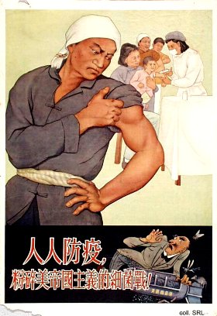
After the Sino-Soviet split in the late 1950s, China virtually had no allies left in the international community. It felt threatened in the North by the military forces of the Soviet Union, which were amassed along the shared Northeastern border, and in the South by the growing military presence of the United States in Southeast Asia. Due to a concrete territorial border conflict, however, the most explicit propaganda about China's fighting resolve was directed against the Soviets.
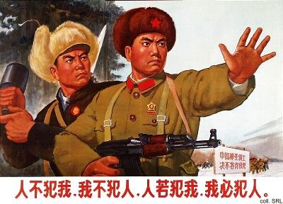
During the initial phase of the Cultural Revolution (1966-1969), China embarked on a crusade against both Soviet revisionism and American imperialism. Other reactionary forces elsewhere were equally combatted, with or without relevant quotes from Mao Zedong Thought. At the same time, protests against the American presence in South Vietnam were recurring themes.
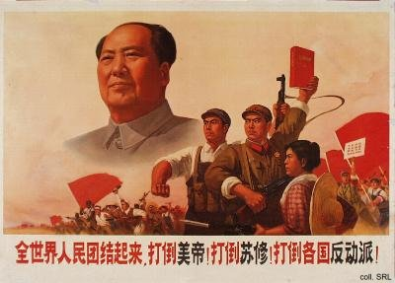
After the normalization of relations with the US in 1972, China ended its more extreme anti-American propaganda. The struggle against the Soviet Union, which was now accused of "socialist imperialism", continued. Only in 1989, relations with Moscow were normalized again.
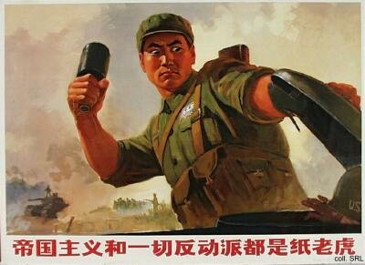

Source:
Ruth Rogaski, "Nature, Annihilation, and Modernity: China's Korean War Germ-Warfare Experience Reconsidered", Journal of Asian Studies, vol. 61, no. 2 (May 2002), pp. 381-415

